EditPlus 3

EditPlus is a text editor, HTML editor, PHP editor, Java editor and Hex Viewer for Windows. While it can serve as a good Notepad replacement, it also offers many powerful features for Web page authors and programmers.

Quick Instalation for smart:
1. Document->Pernament Settings -> Settings & Syntax->Add;
2. Write "AngelScript" or smothing;
3. Syntax File: choose fos.stx;
4. Go to SyntaxColors and modify colors(my settings on screen).

What you can get?
1. Open .fos files in EditPlus by default!
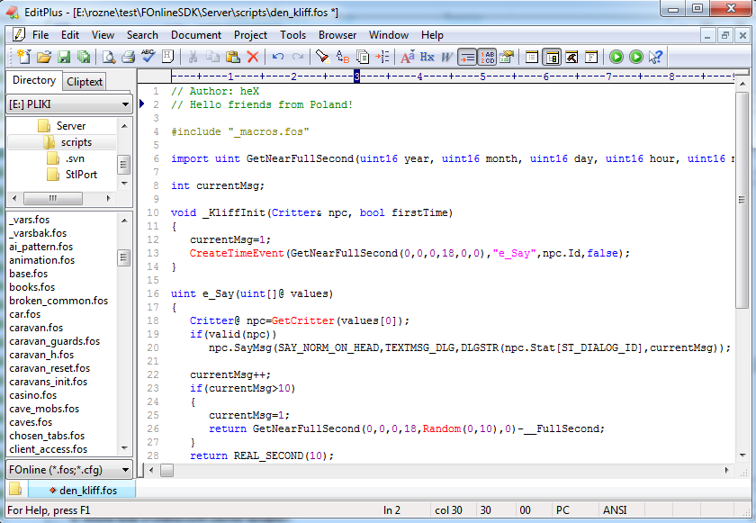Syntax highlighting for AngelScripts, and Fonline API functions!
2. Syntax highlighting for AngelScripts, and Fonline API functions!
3. Detect Functions in module!
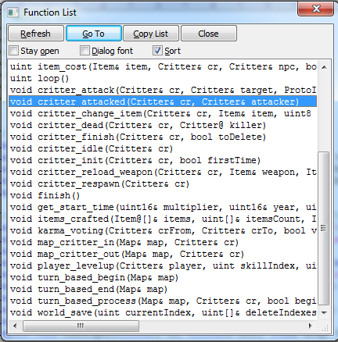Function List, you can move to function, by double click! Specially usefull in big files like main.fos! ctrl+F11

Detailed instruction

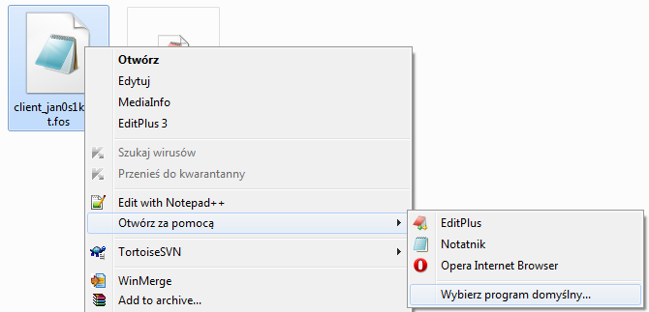
Shift + Right click on .fos file, Open as → Choose default program (or something like thaqt, I don't have english windows)
1. Run EditPlus 3
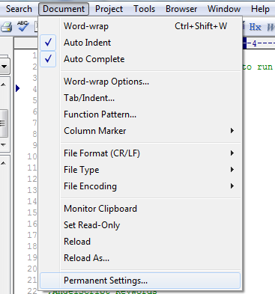
2. Document → Pernament Settings
3. Click Add... Button
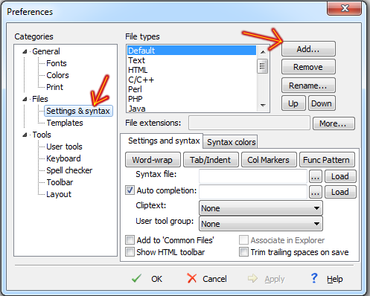
4. Enter File Type Decription. For example: „fos”, „Fonline”, „Foscripts” etc.
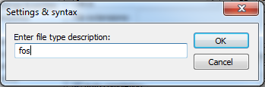
5. Write File extentions: fos, and choose fos.stx in Syntax file
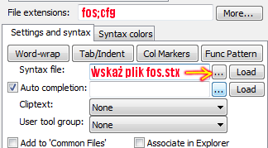
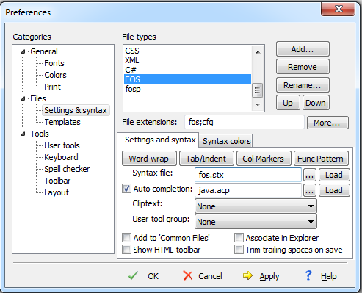
6. Click button "Tab and Ident" and do all as on image
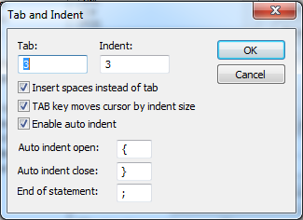
7. Click button "Func Pattern"and do all as on image(copy-paste: ^[A-Za-z_].*\([^;]*$):
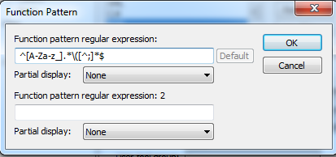
8. Go to „Syntax colors” and set colors that you like:
9. Apply & OK – now you have Syntax higliting in fos files, and you can see functions list by clicking ctrl+F11
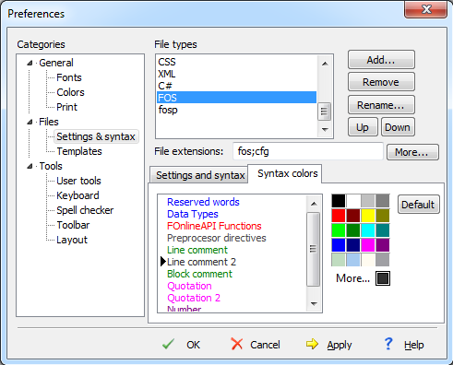Line comment 2 is for #(preprocesor)
How Integrate EditPlus 3 with ASCompiler.exe
1.Tools -> Configure User Tools:
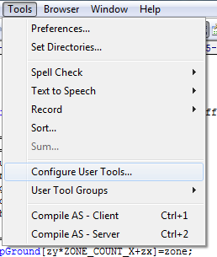
2. Add Tool >> Program
3. In „Menu Text” write name for new tool for compiling Client Scripts, for example: „ASCompiler Client”
4. In Command write patch to ASCompiler.exe, you fund this program in SDK directory \Tools\ASCompiler\
In my case: E:\rozne\test\FOnlineSDK\Tools\ASCompiler\ASCompiler.exe
5. In Argument paste:
$(FileName) as.dll fo_client.dll -d __CLIENT -p $(FileNameNoExt).fosp
6. In Initial Directory paste:
$(FileDir)
7. Set options, as on image, and choose icon:
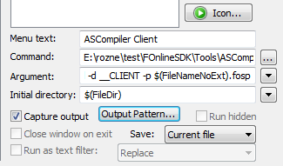
8. The same way, add toolbar for compile server scripts, only diferences are
Menu text: ASCompiler Server
Argument:
$(FileName) as.dll fo.dll -d __SERVER -p $(FileNameNoExt).fosp
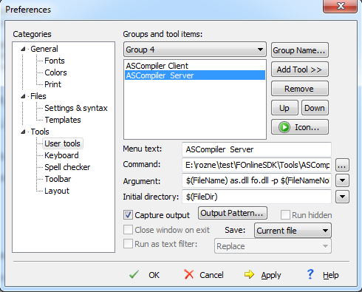
9. Go to Toolbar, in Buttons chose User and add User Tool 1 and User Toll 2:
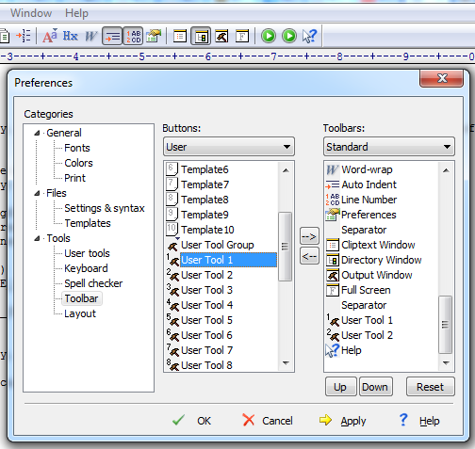
Effect:
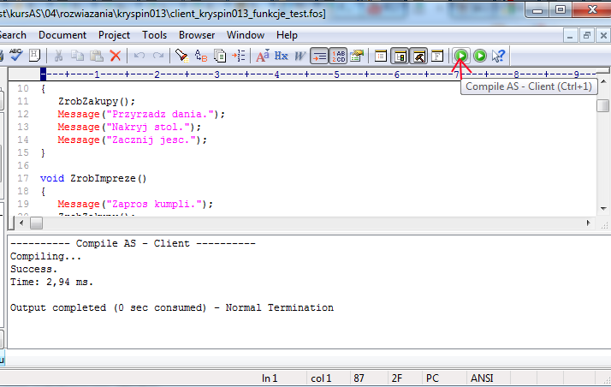You can test scripts file in EditPlus3, without restart server, and see the output!
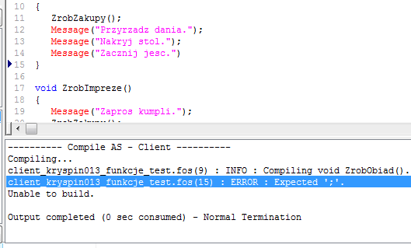Error? No problem!
Thank you for reading. See my Fonline mods, that I write in EditPlus 3!
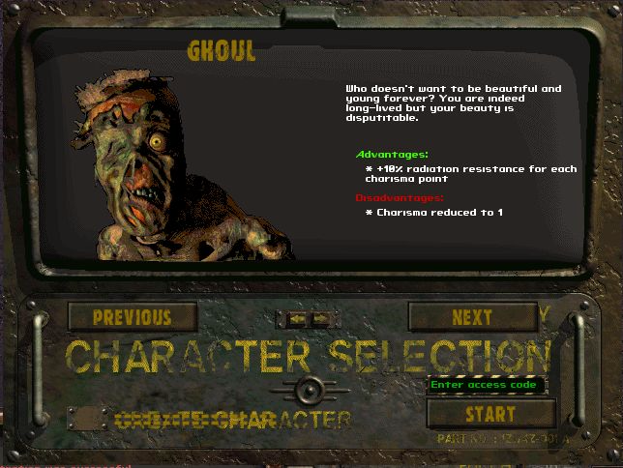
Whant cinematic adventure? See Start location select screen!
http://fonline.ru/forum/showthread.php?t=19834
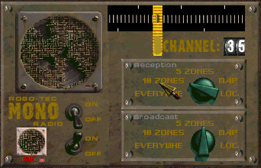
Robo-Tec MONO Radio! - http://fonline.ru/forum/showthread.php?t=19850
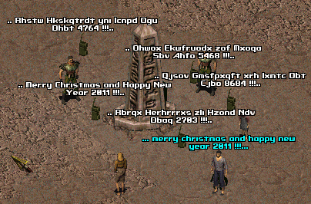
Radio with encryption - http://fonline.ru/forum/showthread.php?t=19890

By Miki

Feedback: http://www.fonline.ru/forum/showthread.php?t=20680

